0 = control

1 = 0.25

2=0.5

3=1

4=2

5=4

6=8

Train both day together

|  |
| --- |
| Train: [ 0 1 2 3 4 5 6 7 8 9 10 11 12 13 14 15 16 17 18 19 20 21 23 24  25 26 27 28 30 31 32 33 34 35 36 37] Validation: [22 29]  Train: [ 0 1 2 3 4 5 6 7 8 9 10 11 12 13 14 17 18 19 20 21 22 23 24 25  26 27 28 29 30 31 32 33 34 35 36 37] Validation: [15 16]  Train: [ 0 1 2 3 4 5 6 7 8 9 10 12 13 14 15 16 17 18 19 21 22 23 24 25  26 27 28 29 30 31 32 33 34 35 36 37] Validation: [11 20]  Train: [ 0 1 2 3 4 5 6 7 8 9 11 12 13 14 15 16 17 18 19 20 21 22 23 24  25 27 28 29 30 31 32 33 34 35 36 37] Validation: [10 26]  Train: [ 0 1 3 4 5 6 7 8 9 10 11 12 13 14 15 16 17 18 19 20 21 22 23 24  26 27 28 29 30 31 32 33 34 35 36 37] Validation: [ 2 25]  Train: [ 0 1 2 3 4 5 6 7 8 9 10 11 12 13 14 15 16 17 18 19 20 21 22 23  24 25 26 27 28 29 30 32 34 35 36 37] Validation: [31 33]  Train: [ 0 1 2 3 4 5 6 7 8 9 10 11 12 13 14 15 16 17 18 19 20 21 22 23  24 25 26 27 28 29 30 31 33 34 35 36] Validation: [32 37]  Train: [ 0 1 2 3 4 5 6 7 8 9 10 11 12 13 14 15 16 17 18 19 20 21 22 23  24 25 26 27 28 29 31 32 33 34 36 37] Validation: [30 35]  Train: [ 0 1 2 3 4 5 6 7 9 10 11 12 13 14 15 16 17 18 19 20 21 22 23 24  25 26 27 28 29 30 31 32 33 35 36 37] Validation: [ 8 34]  Train: [ 0 1 2 3 4 6 7 8 9 10 11 12 14 15 16 17 18 19 20 21 22 23 24 25  26 27 28 29 30 31 32 33 34 35 36 37] Validation: [ 5 13]  Train: [ 0 1 2 3 4 5 6 7 8 9 10 11 12 13 15 16 18 19 20 21 22 23 24 25  26 27 28 29 30 31 32 33 34 35 36 37] Validation: [14 17]  Train: [ 0 1 2 3 4 5 6 8 9 10 11 12 13 14 15 16 17 18 19 20 21 22 23 24  25 26 27 29 30 31 32 33 34 35 36 37] Validation: [ 7 28]  Train: [ 0 2 3 4 5 6 7 8 9 10 11 13 14 15 16 17 18 19 20 21 22 23 24 25  26 27 28 29 30 31 32 33 34 35 36 37] Validation: [ 1 12]  Train: [ 0 1 2 3 4 5 6 7 8 9 10 11 12 13 14 15 16 17 18 19 20 21 22 23  25 26 28 29 30 31 32 33 34 35 36 37] Validation: [24 27]  Train: [ 0 1 2 3 4 5 7 8 9 10 11 12 13 14 15 16 17 18 19 20 21 22 24 25  26 27 28 29 30 31 32 33 34 35 36 37] Validation: [ 6 23]  Train: [ 0 1 2 3 5 6 7 8 9 10 11 12 13 14 15 16 17 19 20 21 22 23 24 25  26 27 28 29 30 31 32 33 34 35 36 37] Validation: [ 4 18]  Train: [ 0 1 2 3 4 5 6 7 8 9 10 11 12 13 14 15 16 17 18 20 22 23 24 25  26 27 28 29 30 31 32 33 34 35 36 37] Validation: [19 21]  Train: [ 0 1 2 3 4 5 6 7 8 10 11 12 13 14 15 16 17 18 19 20 21 22 23 24  25 26 27 28 29 30 31 32 33 34 35 37] Validation: [ 9 36]  Train: [ 1 2 4 5 6 7 8 9 10 11 12 13 14 15 16 17 18 19 20 21 22 23 24 25  26 27 28 29 30 31 32 33 34 35 36 37] Validation: [0 3]  Random Forest Accuracy: 0.8157894736842105  Naive Bayes Accuracy: 0.8157894736842105  Decision Tree Accuracy: 0.8157894736842105 |

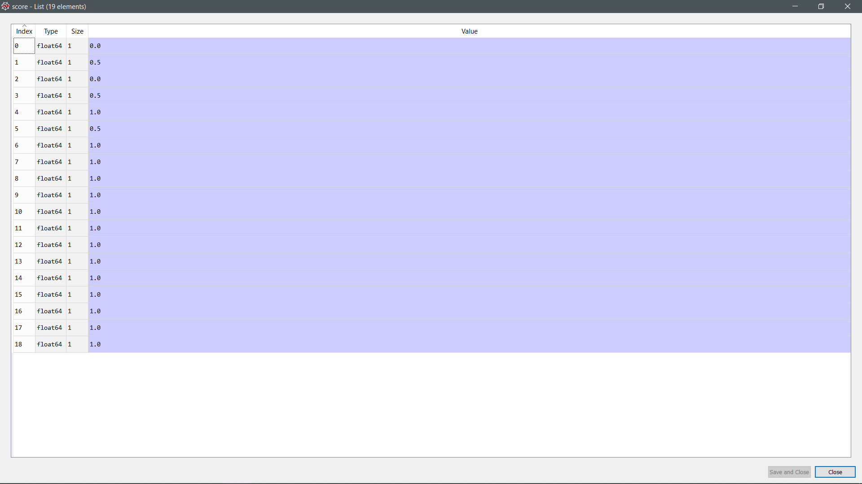

Accuracy of prediction (Random forest)

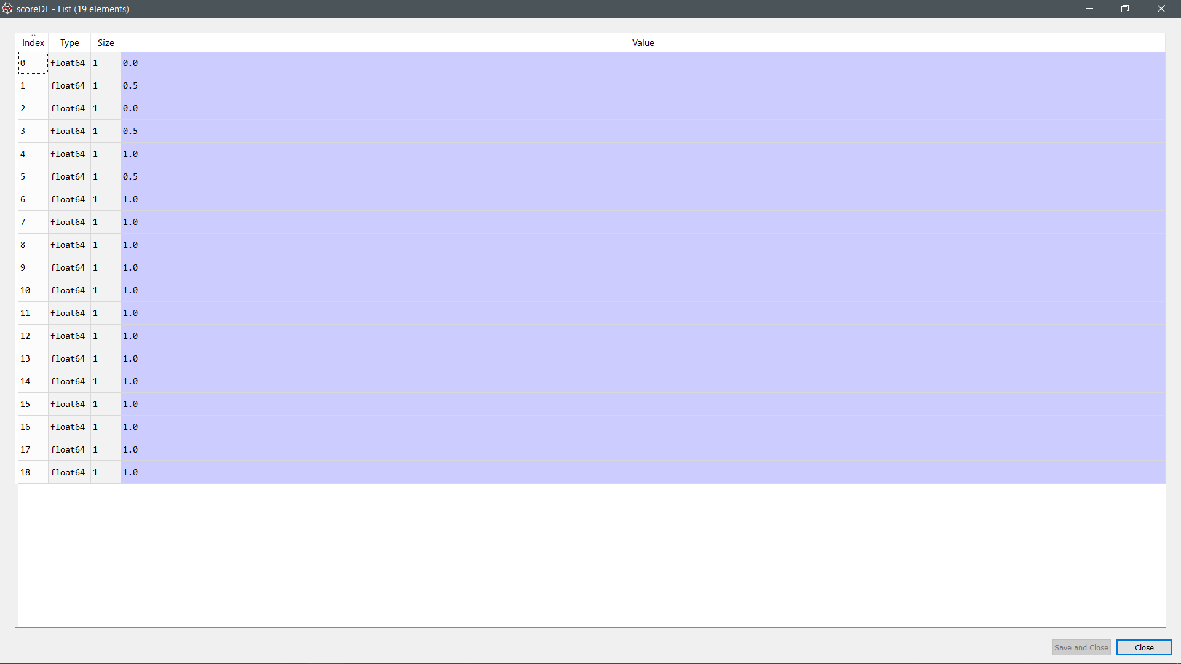

Accuracy of prediction (Decision Tree)

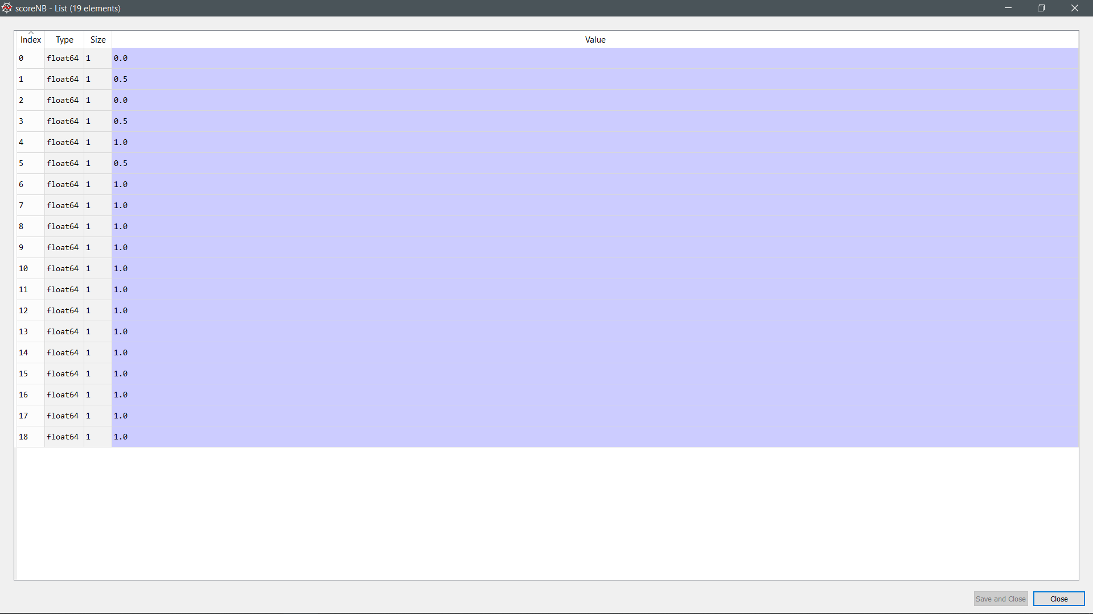

Accuracy of prediction (Naive Bayes)

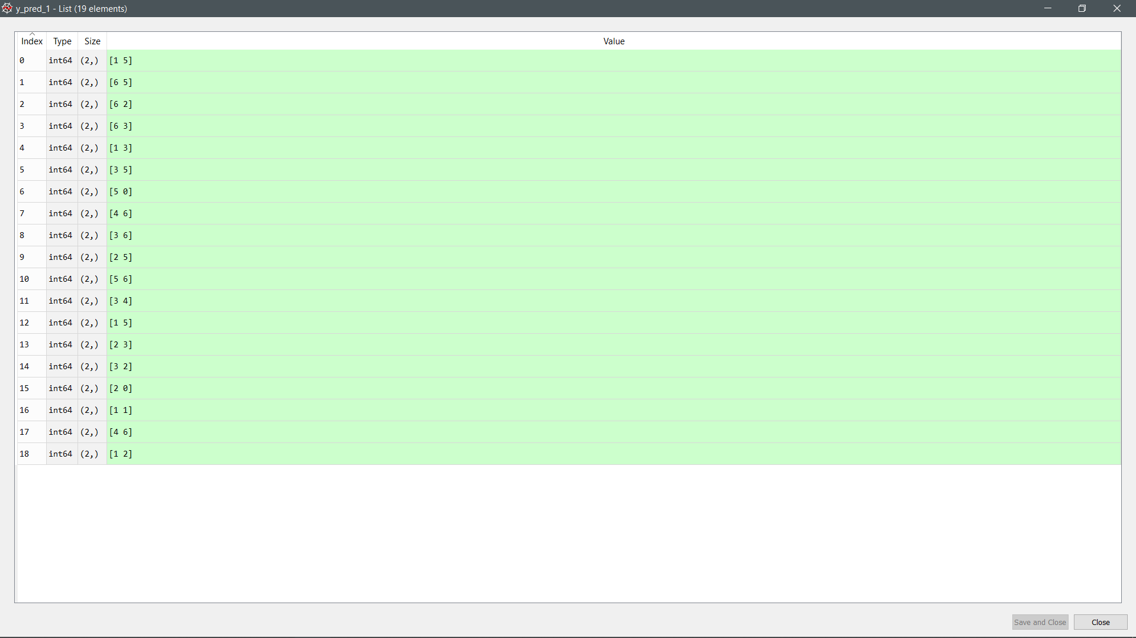

Prediction made by the model (Random forest)

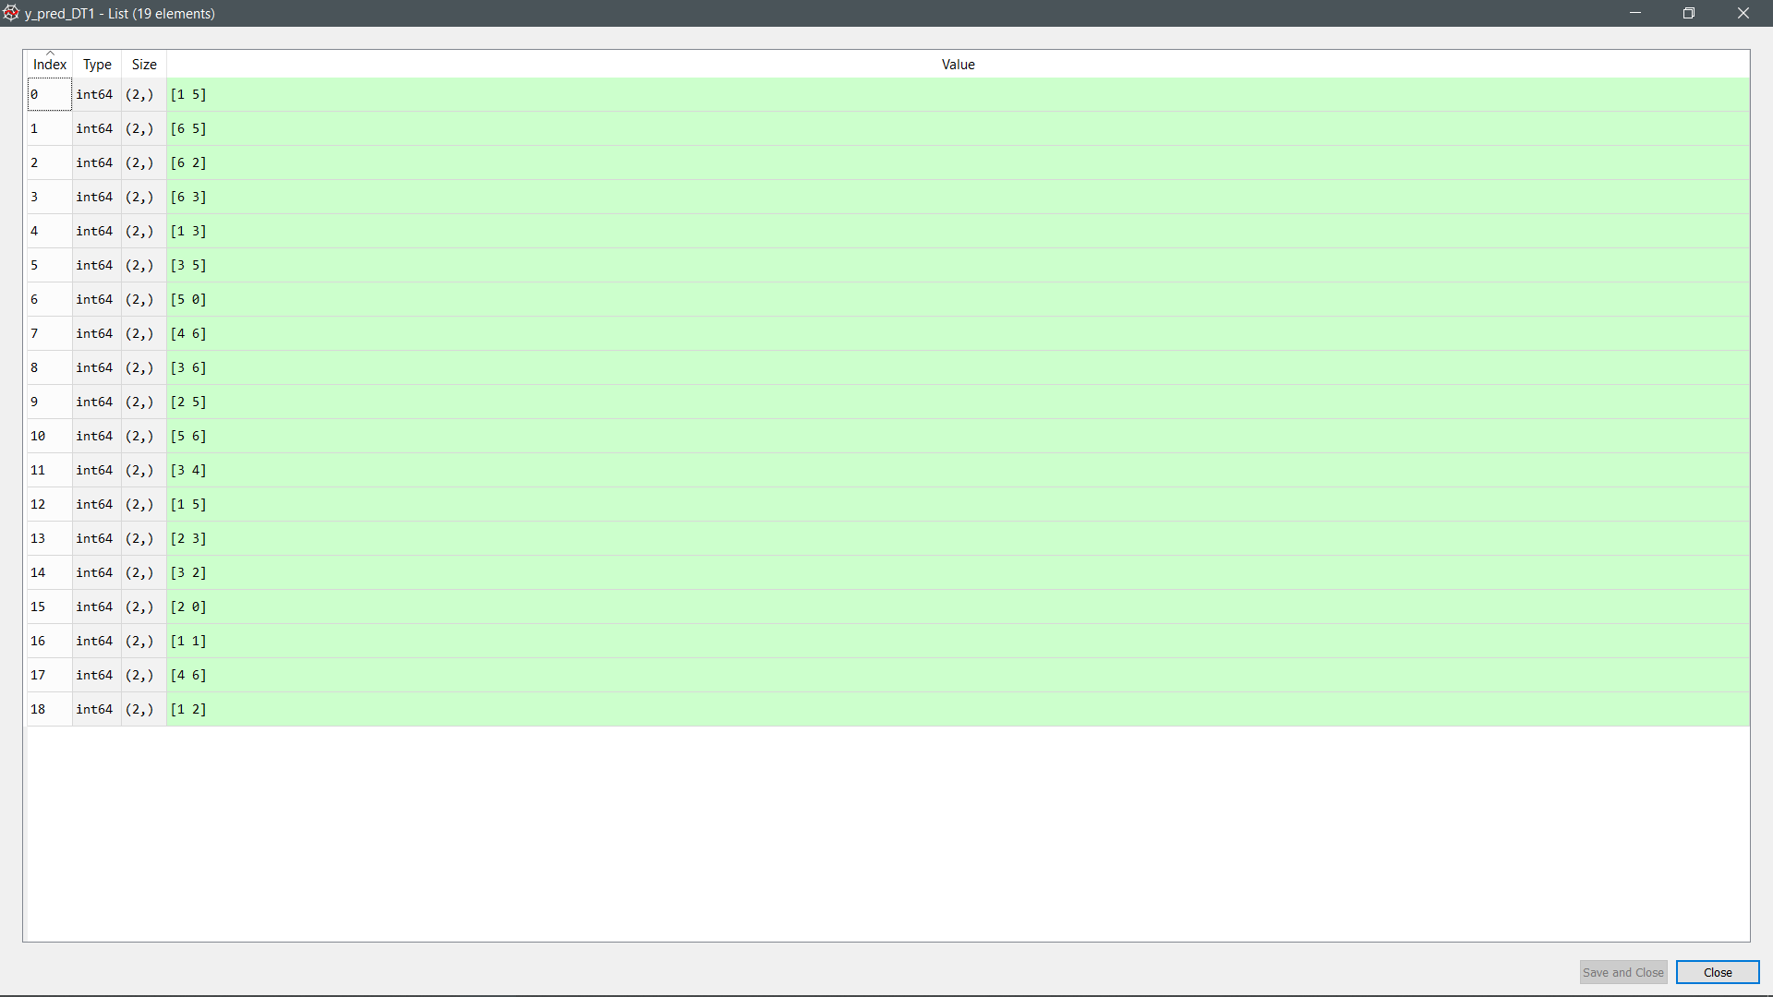

Prediction made by the model (Decision Tree)

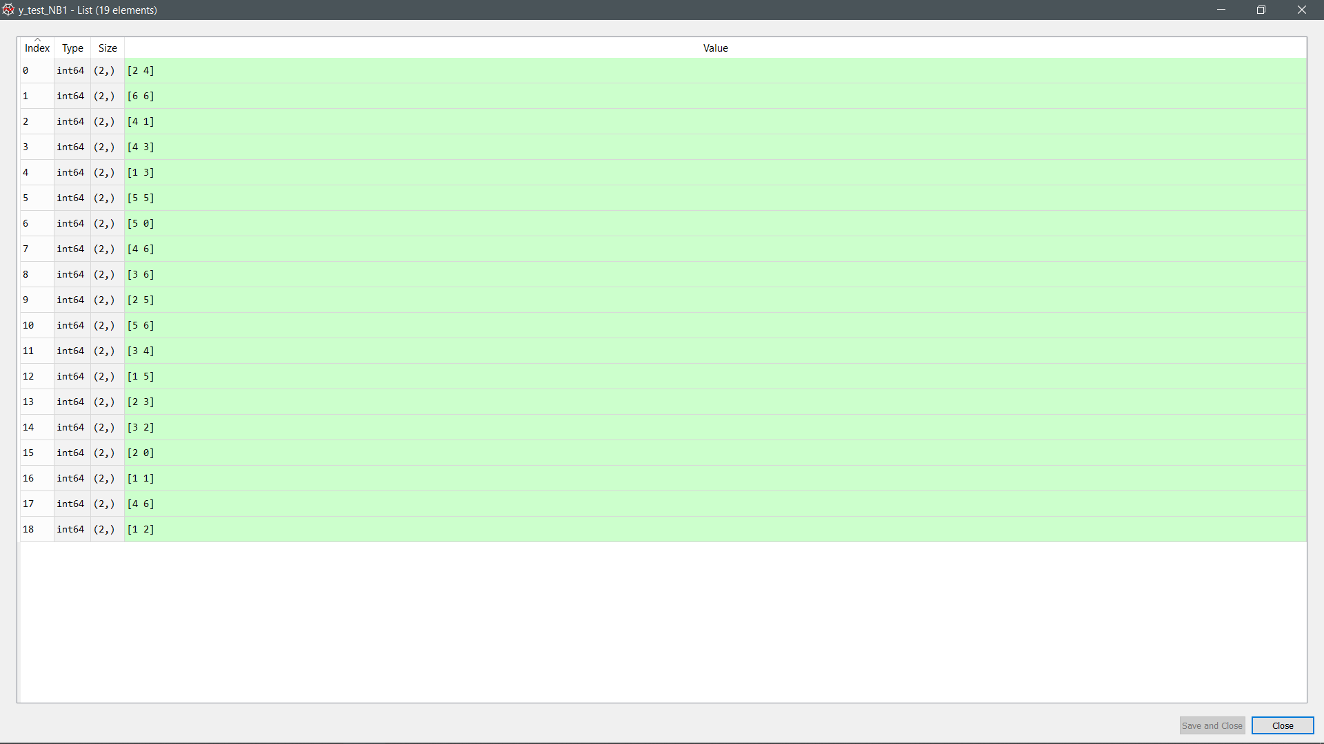

Prediction made by the model (Naïve Bayes)

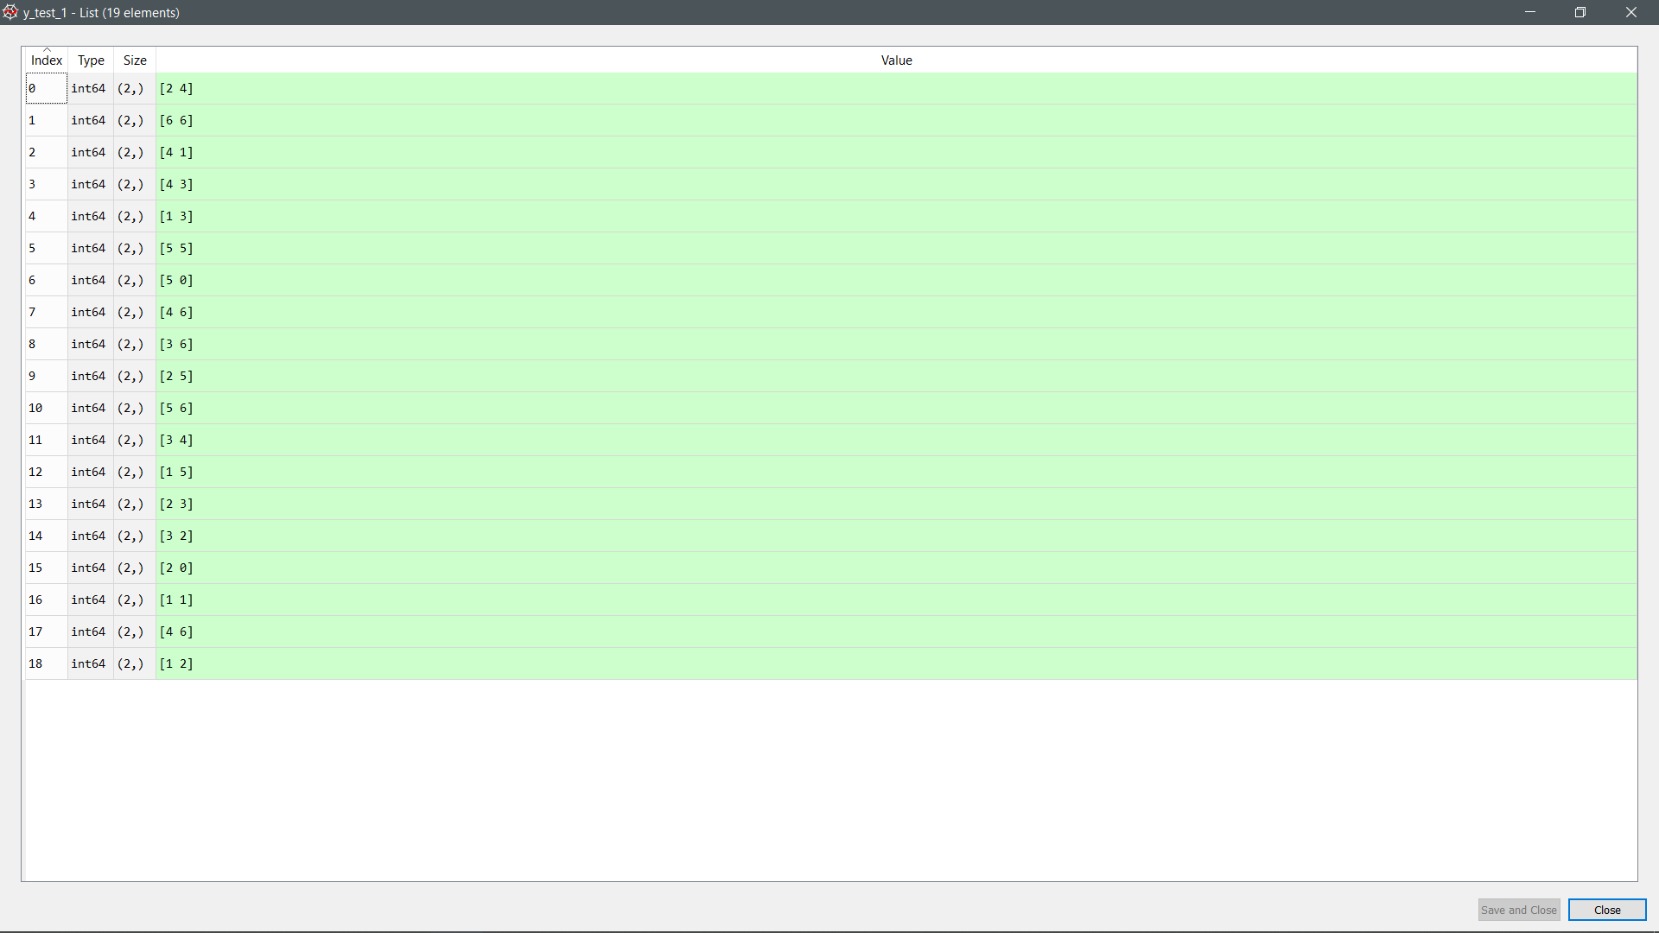

Actual value (Random Forest)

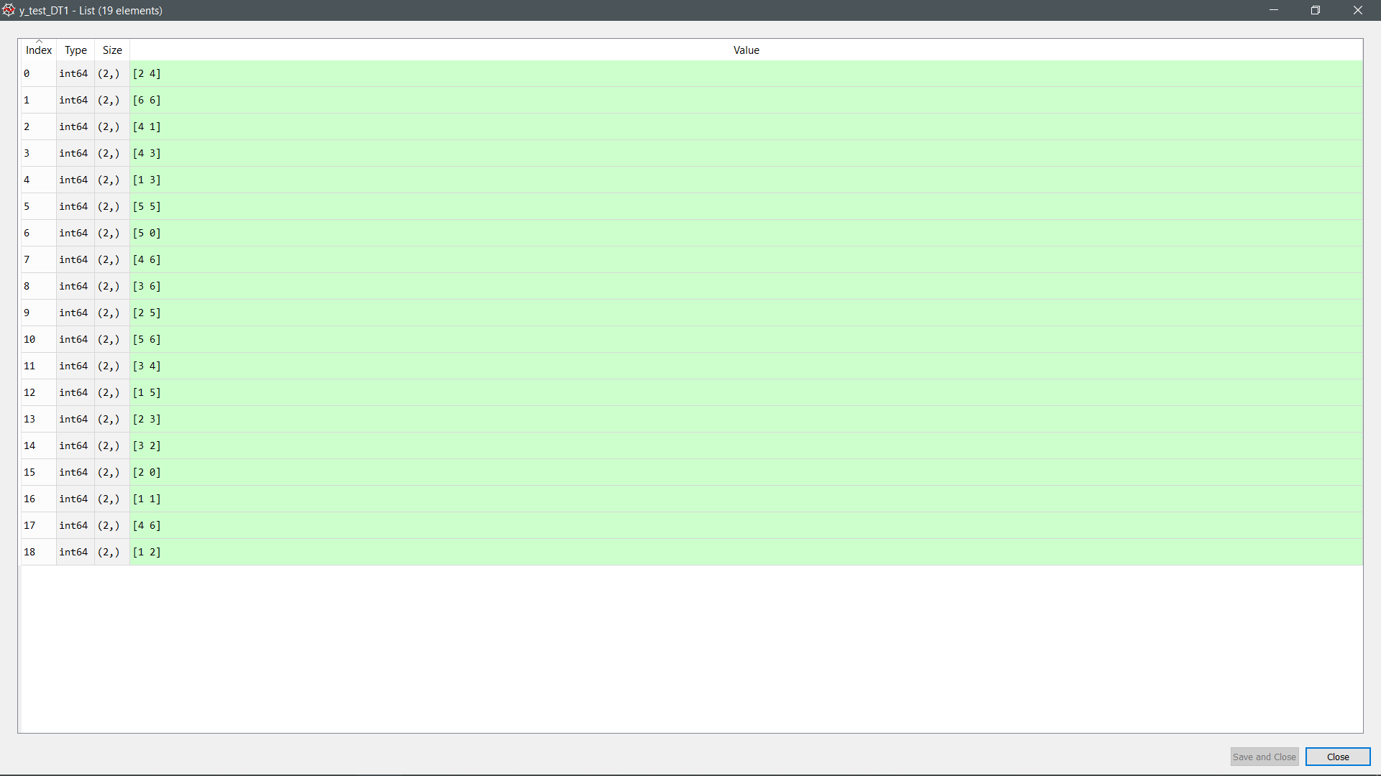

Actual value (Decision Tree)

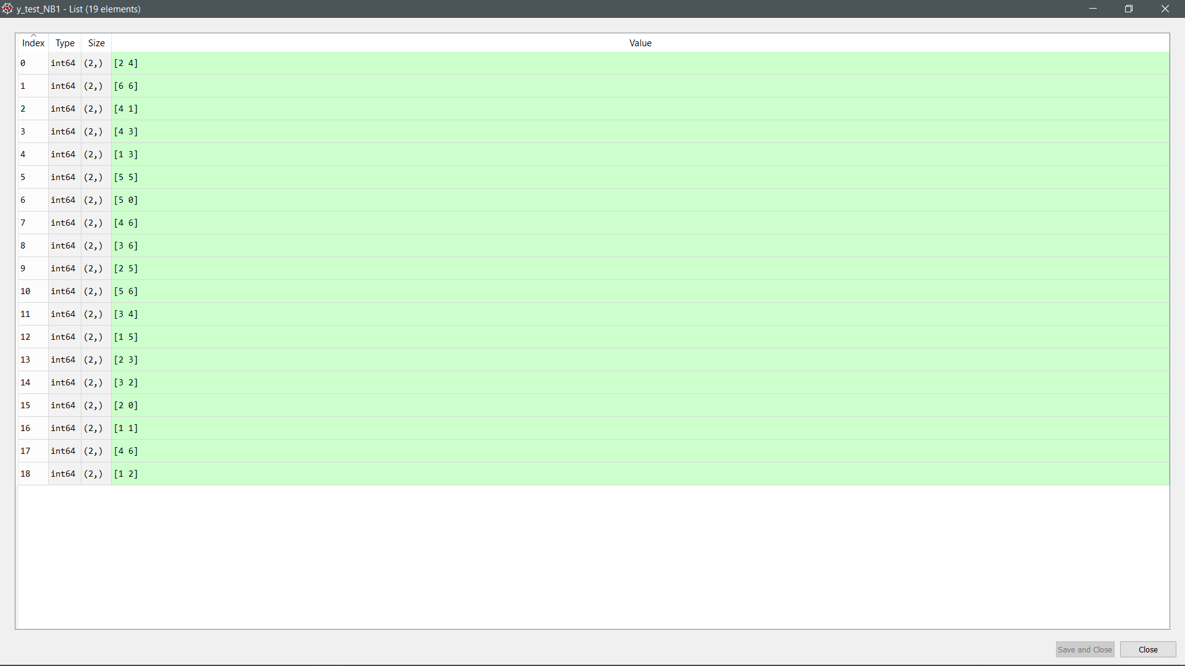

Actual value (Naïve Bayes)

|  |
| --- |
| Day 1 only  Train: [ 0 1 2 3 4 5 6 7 8 9 11 12 13 14 15 16 17 18] Validation: [10]  Train: [ 0 2 3 4 5 6 7 8 9 10 11 12 13 14 15 16 17 18] Validation: [1]  Train: [ 0 1 2 3 4 5 6 7 9 10 11 12 13 14 15 16 17 18] Validation: [8]  Train: [ 0 1 2 3 4 5 6 7 8 9 10 11 12 13 14 15 16 17] Validation: [18]  Train: [ 0 1 2 3 4 5 6 7 8 9 10 11 12 13 15 16 17 18] Validation: [14]  Train: [ 0 1 2 3 4 5 6 7 8 9 10 11 12 13 14 15 17 18] Validation: [16]  Train: [ 0 1 2 3 4 5 7 8 9 10 11 12 13 14 15 16 17 18] Validation: [6]  Train: [ 0 1 2 3 5 6 7 8 9 10 11 12 13 14 15 16 17 18] Validation: [4]  Train: [ 0 1 3 4 5 6 7 8 9 10 11 12 13 14 15 16 17 18] Validation: [2]  Train: [ 0 1 2 3 4 6 7 8 9 10 11 12 13 14 15 16 17 18] Validation: [5]  Train: [ 0 1 2 3 4 5 6 7 8 9 10 11 12 14 15 16 17 18] Validation: [13]  Train: [ 0 1 2 3 4 5 6 7 8 10 11 12 13 14 15 16 17 18] Validation: [9]  Train: [ 0 1 2 3 4 5 6 8 9 10 11 12 13 14 15 16 17 18] Validation: [7]  Train: [ 0 1 2 3 4 5 6 7 8 9 10 11 12 13 14 15 16 18] Validation: [17]  Train: [ 0 1 2 3 4 5 6 7 8 9 10 12 13 14 15 16 17 18] Validation: [11]  Train: [ 0 1 2 4 5 6 7 8 9 10 11 12 13 14 15 16 17 18] Validation: [3]  Train: [ 1 2 3 4 5 6 7 8 9 10 11 12 13 14 15 16 17 18] Validation: [0]  Train: [ 0 1 2 3 4 5 6 7 8 9 10 11 12 13 14 16 17 18] Validation: [15]  Train: [ 0 1 2 3 4 5 6 7 8 9 10 11 13 14 15 16 17 18] Validation: [12]  Random Forest Accuracy: 0.9473684210526315  Naive Bayes Accuracy: 0.9473684210526315  Decision Tree Accuracy: 0.9473684210526315 |

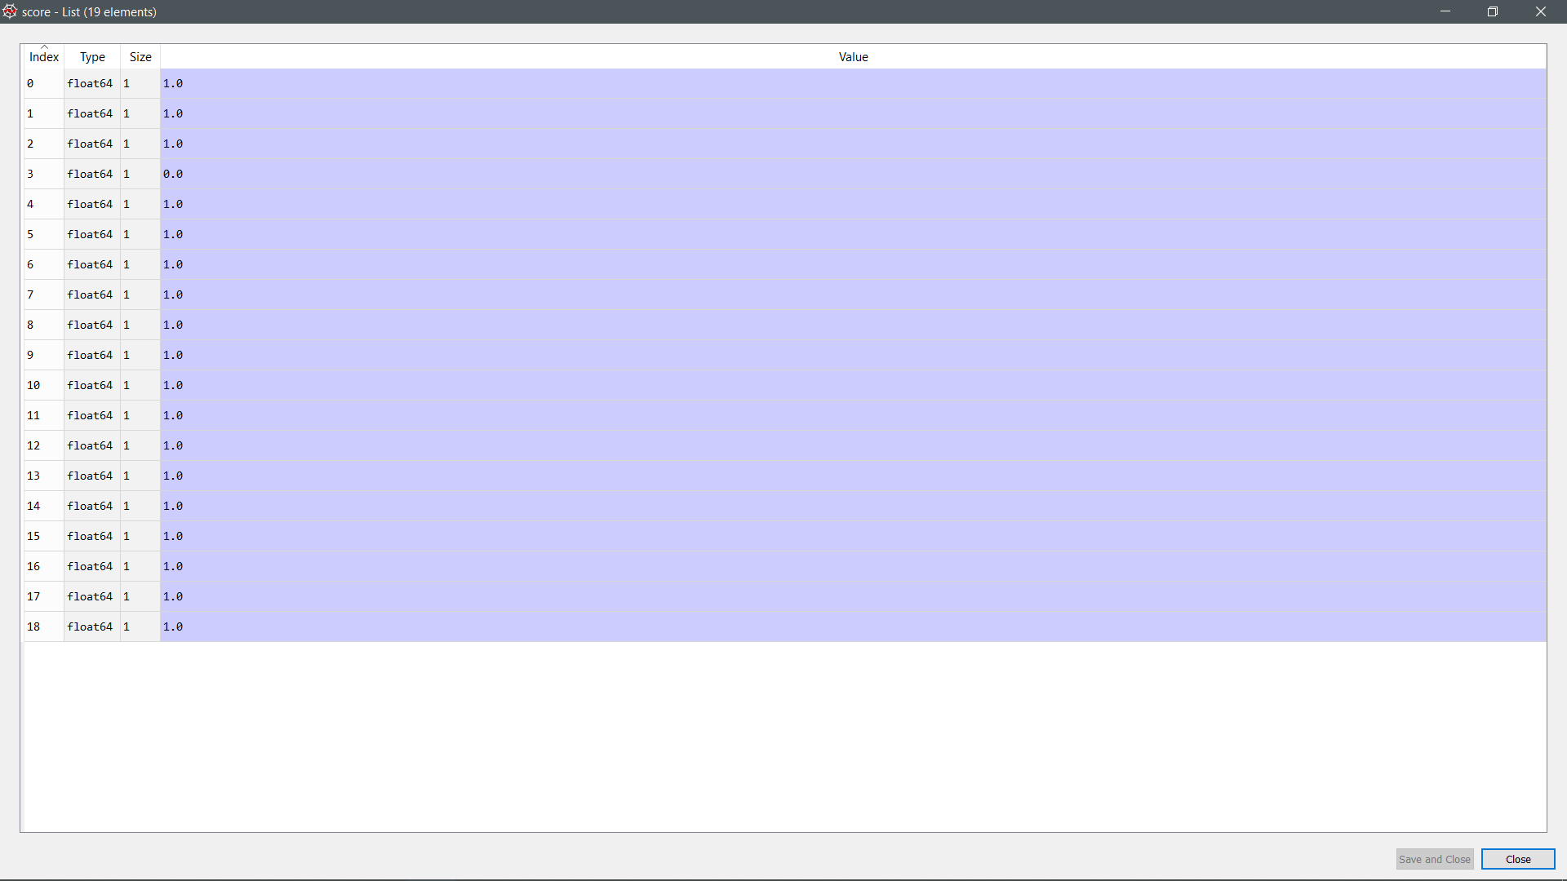

Accuracy of prediction (Random forest)

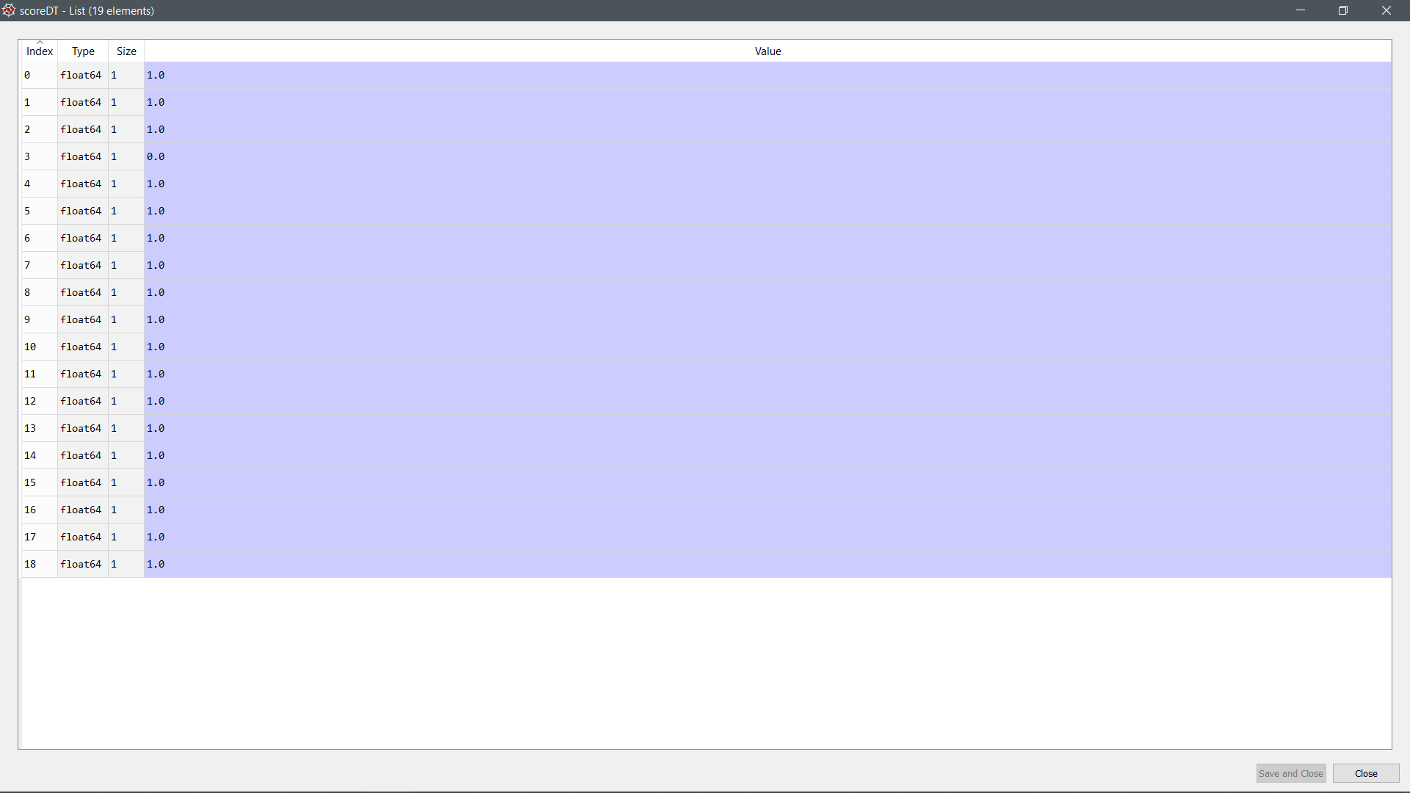

Accuracy of prediction (Decision Tree)

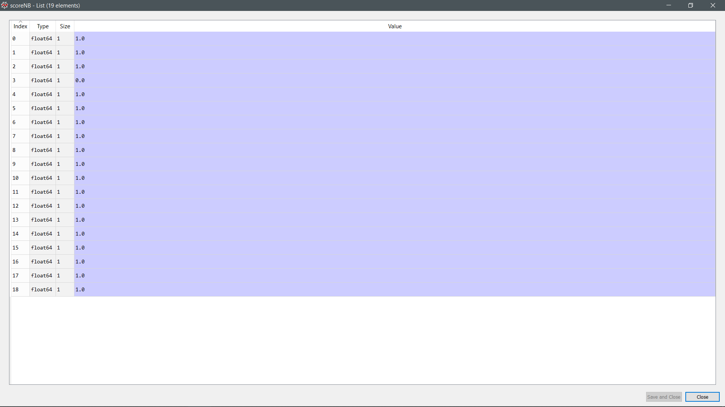

Accuracy of prediction (Naïve Bayes)

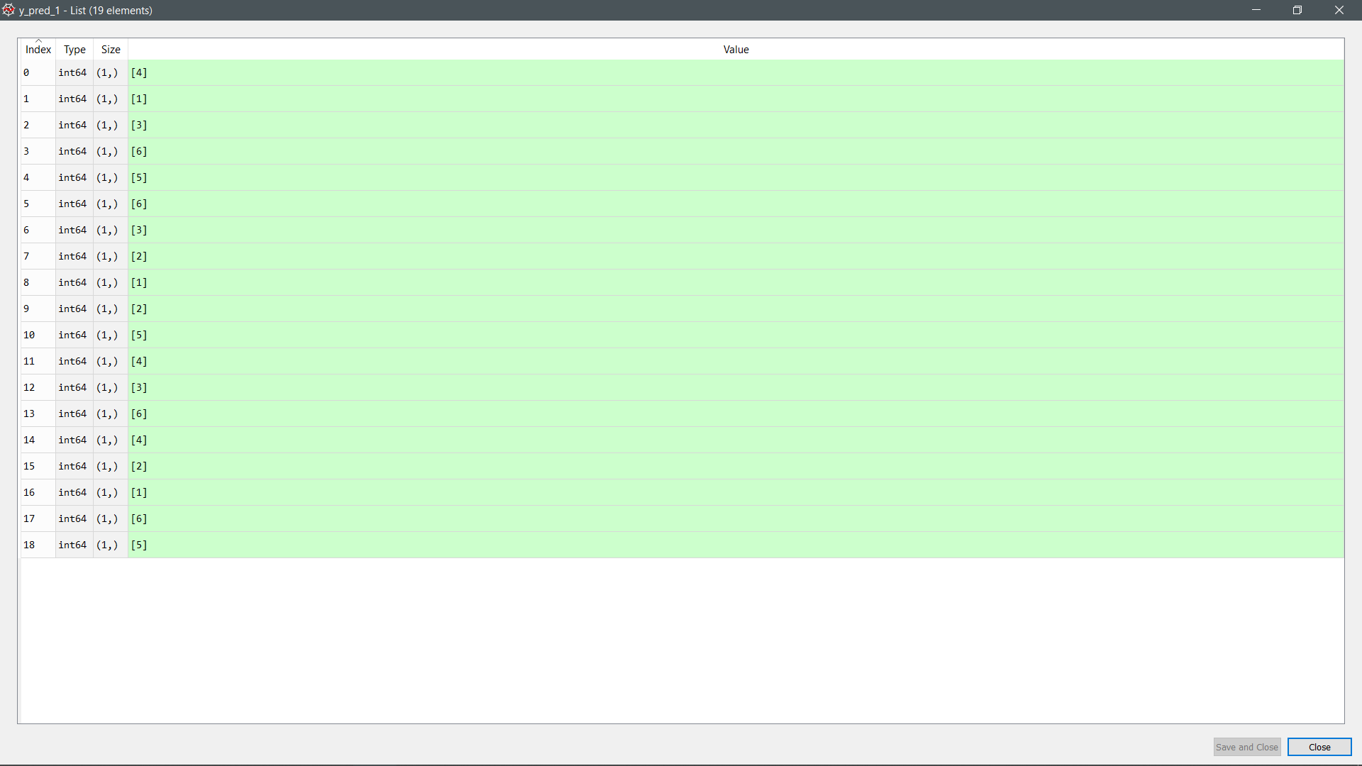

Prediction made by the model (Random forest)

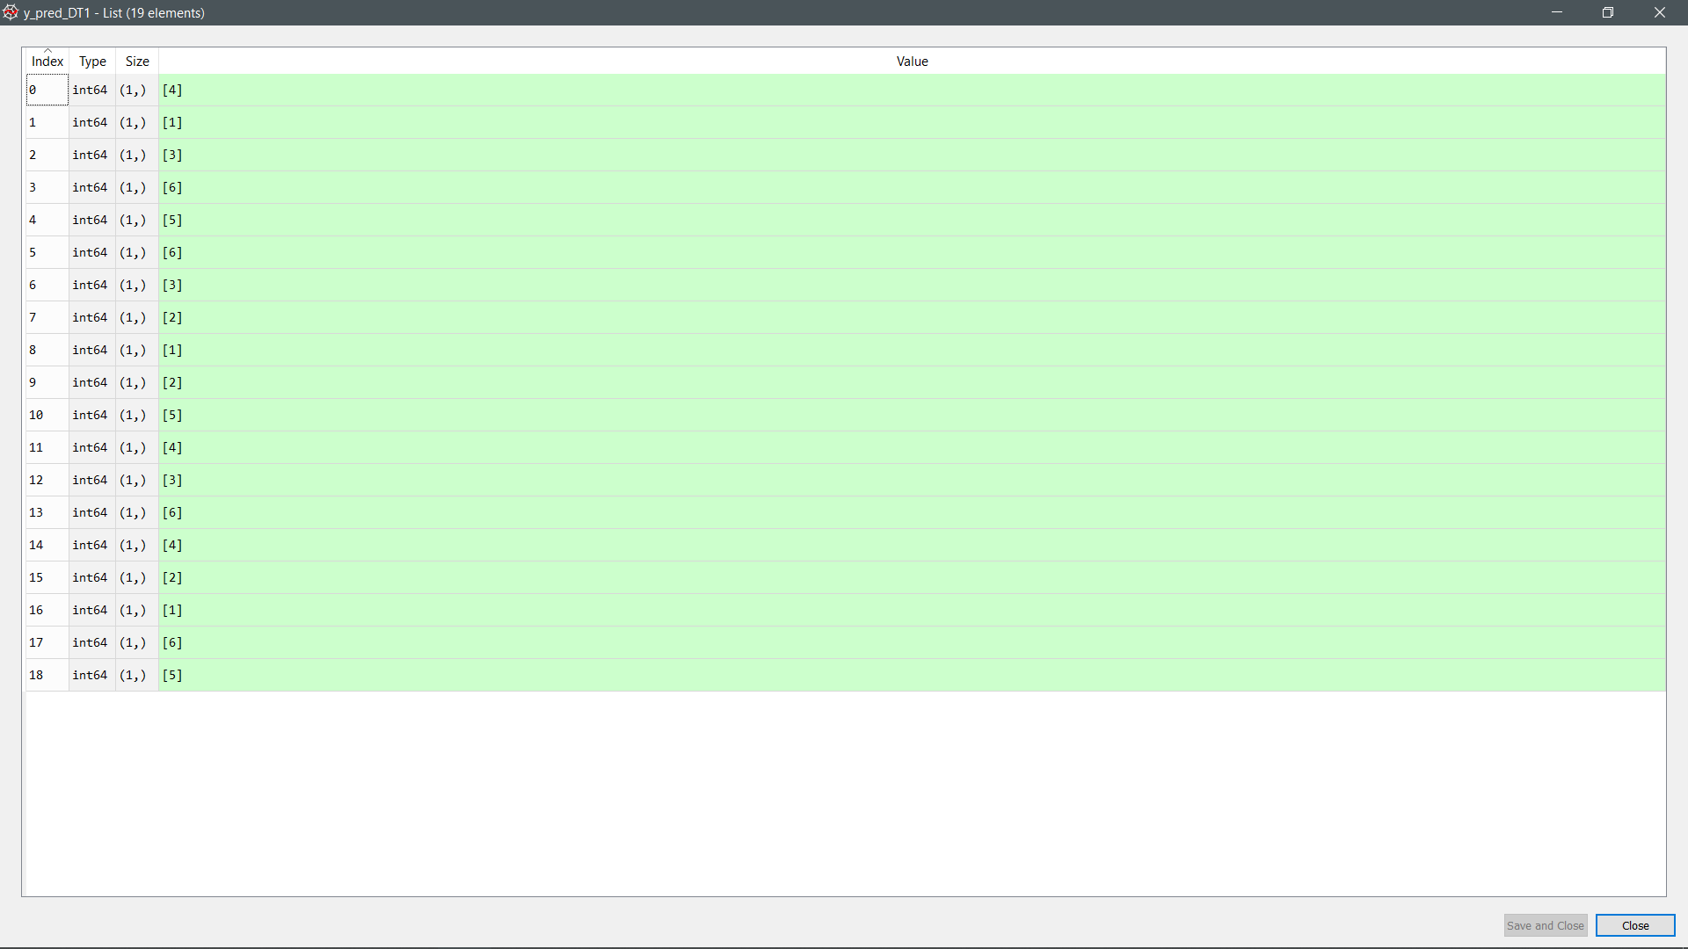

Prediction made by the model (Decision Tree)

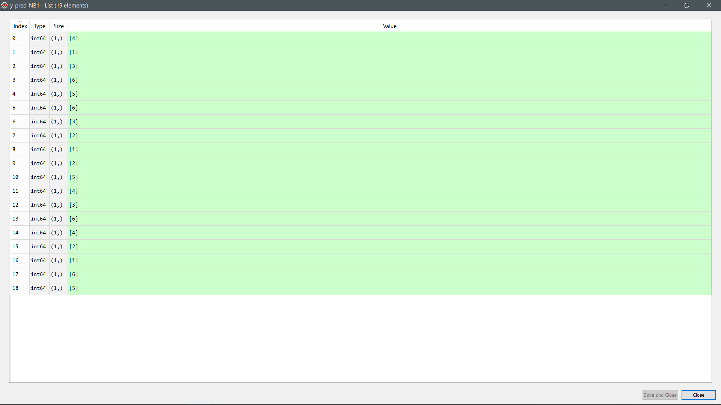

Prediction made by the model (Naive Bayes)

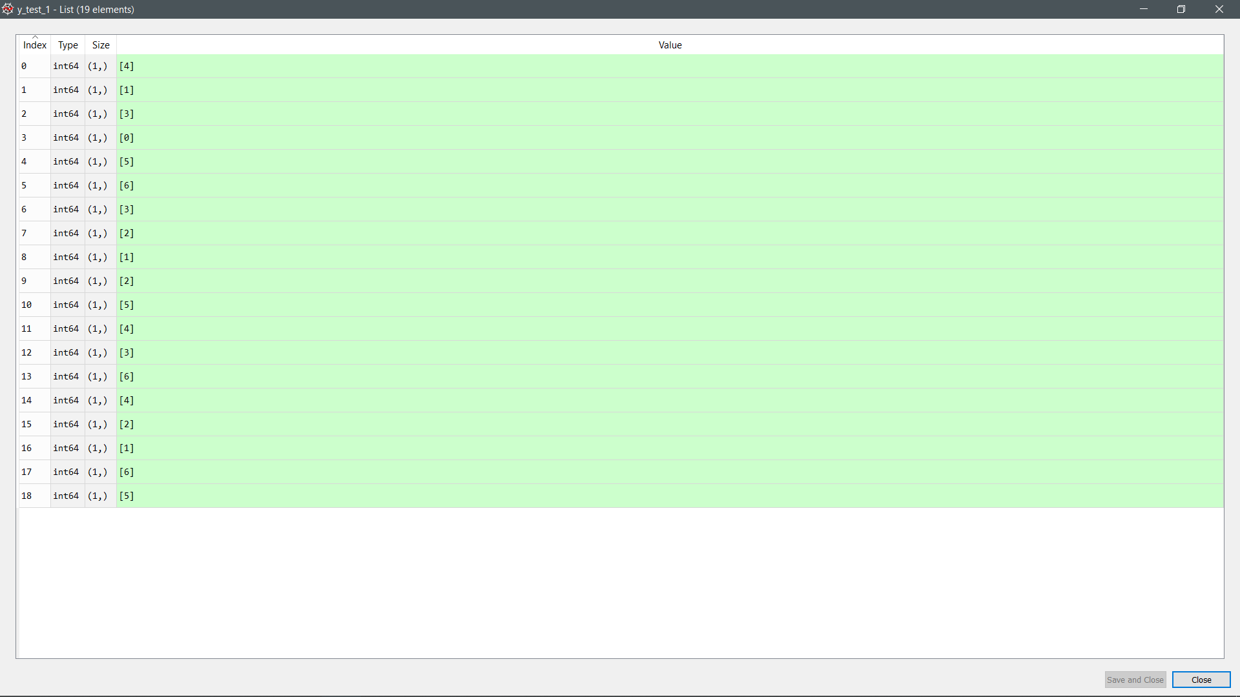

Actual value (Random Forest)

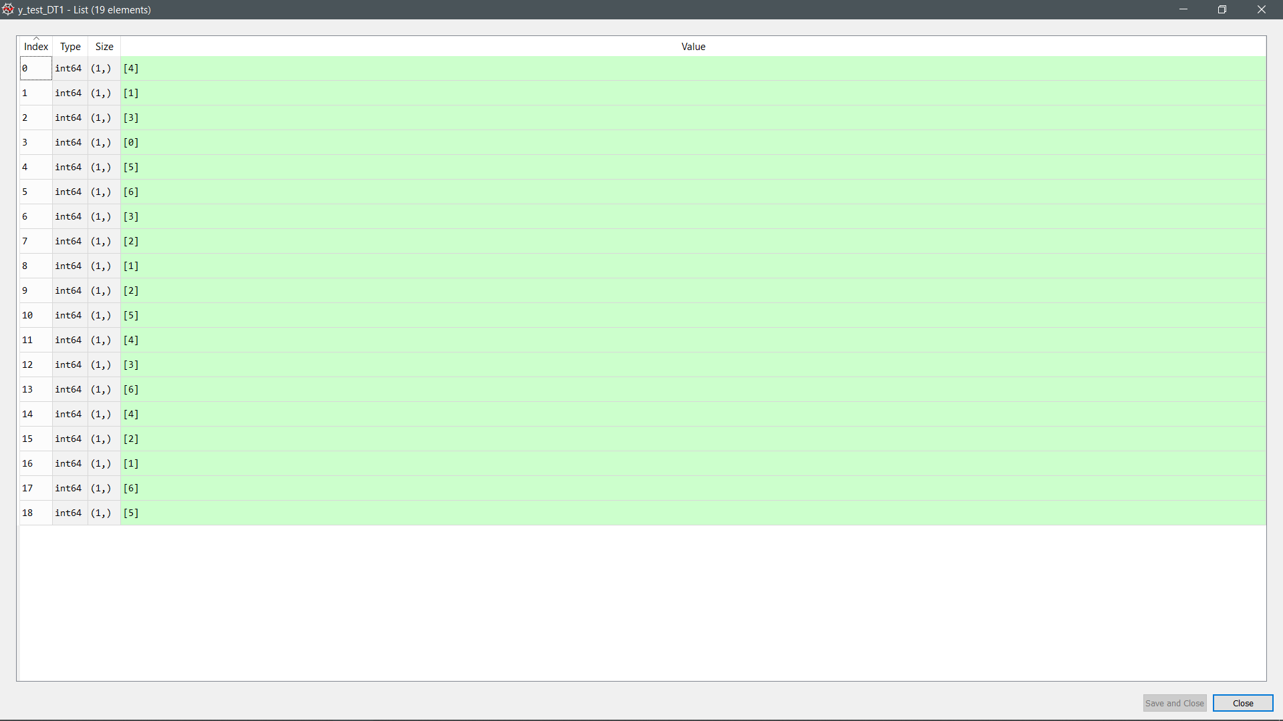

Actual value (Decision Tree)

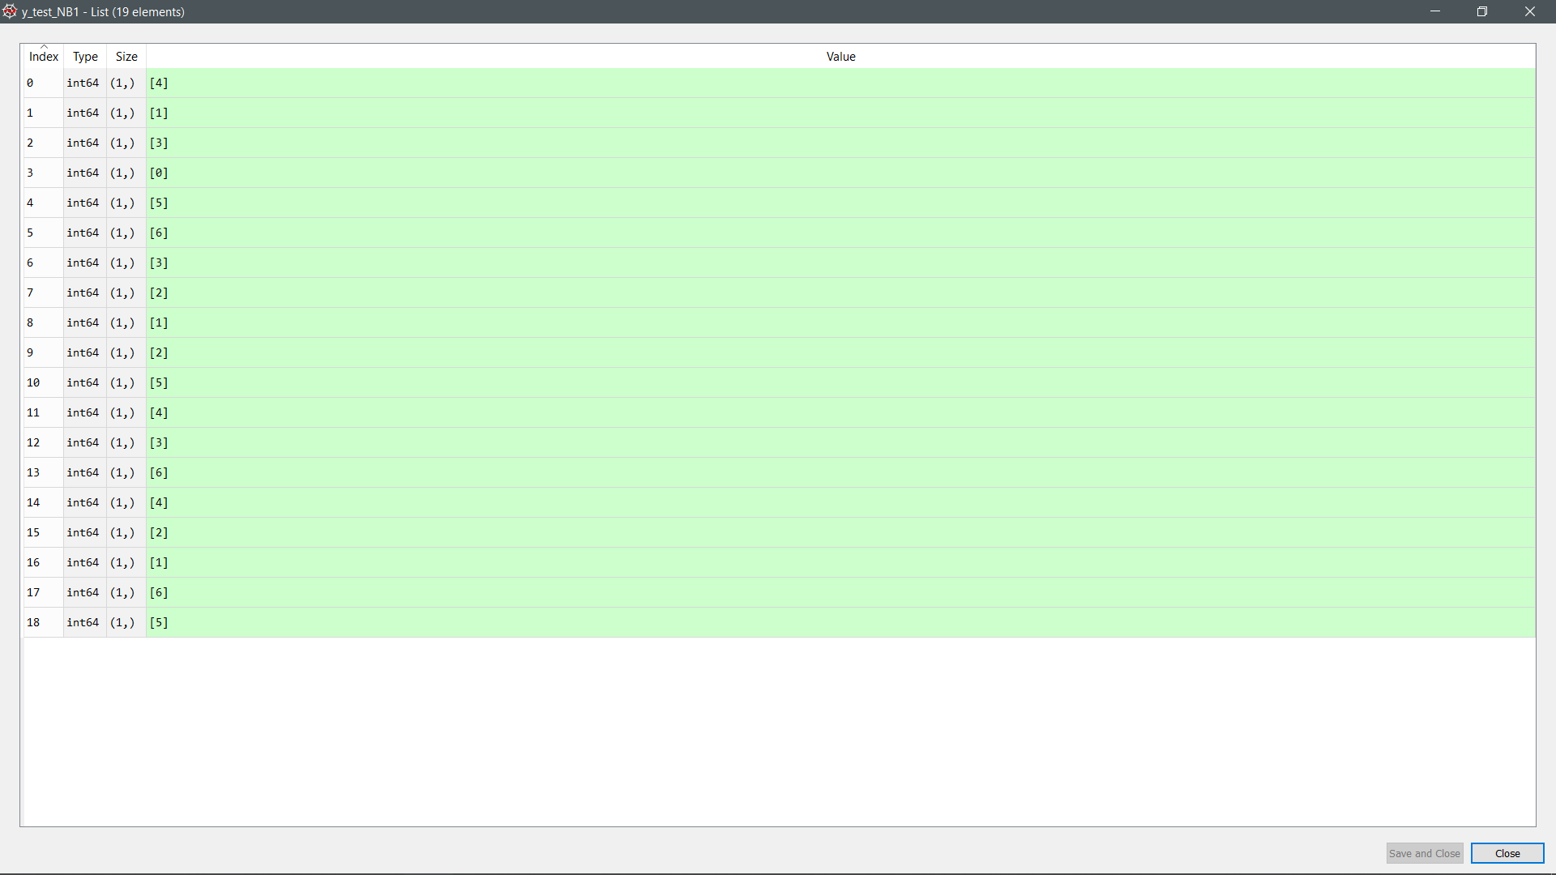

Actual value (Naïve Bayes)

|  |
| --- |
| Day2 only  Train: [ 0 1 2 3 4 5 6 7 8 9 11 12 13 14 15 16 17 18] Validation: [10]  Train: [ 0 2 3 4 5 6 7 8 9 10 11 12 13 14 15 16 17 18] Validation: [1]  Train: [ 0 1 2 3 4 5 6 7 9 10 11 12 13 14 15 16 17 18] Validation: [8]  Train: [ 0 1 2 3 4 5 6 7 8 9 10 11 12 13 14 15 16 17] Validation: [18]  Train: [ 0 1 2 3 4 5 6 7 8 9 10 11 12 13 15 16 17 18] Validation: [14]  Train: [ 0 1 2 3 4 5 6 7 8 9 10 11 12 13 14 15 17 18] Validation: [16]  Train: [ 0 1 2 3 4 5 7 8 9 10 11 12 13 14 15 16 17 18] Validation: [6]  Train: [ 0 1 2 3 5 6 7 8 9 10 11 12 13 14 15 16 17 18] Validation: [4]  Train: [ 0 1 3 4 5 6 7 8 9 10 11 12 13 14 15 16 17 18] Validation: [2]  Train: [ 0 1 2 3 4 6 7 8 9 10 11 12 13 14 15 16 17 18] Validation: [5]  Train: [ 0 1 2 3 4 5 6 7 8 9 10 11 12 14 15 16 17 18] Validation: [13]  Train: [ 0 1 2 3 4 5 6 7 8 10 11 12 13 14 15 16 17 18] Validation: [9]  Train: [ 0 1 2 3 4 5 6 8 9 10 11 12 13 14 15 16 17 18] Validation: [7]  Train: [ 0 1 2 3 4 5 6 7 8 9 10 11 12 13 14 15 16 18] Validation: [17]  Train: [ 0 1 2 3 4 5 6 7 8 9 10 12 13 14 15 16 17 18] Validation: [11]  Train: [ 0 1 2 4 5 6 7 8 9 10 11 12 13 14 15 16 17 18] Validation: [3]  Train: [ 1 2 3 4 5 6 7 8 9 10 11 12 13 14 15 16 17 18] Validation: [0]  Train: [ 0 1 2 3 4 5 6 7 8 9 10 11 12 13 14 16 17 18] Validation: [15]  Train: [ 0 1 2 3 4 5 6 7 8 9 10 11 13 14 15 16 17 18] Validation: [12]  Random Forest Accuracy: 0.9473684210526315  Naive Bayes Accuracy: 0.9473684210526315  Decision Tree Accuracy: 0.9473684210526315 |



Accuracy of prediction (Random Forest)

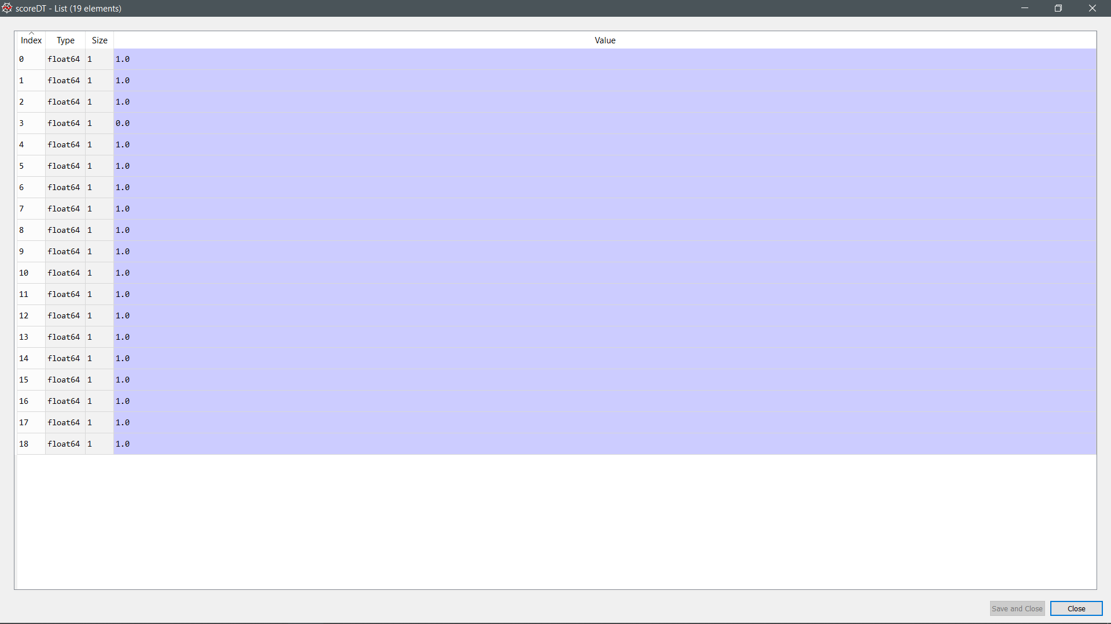

Accuracy of prediction (Decision Tree)



Accuracy of prediction (Naïve Bayes)

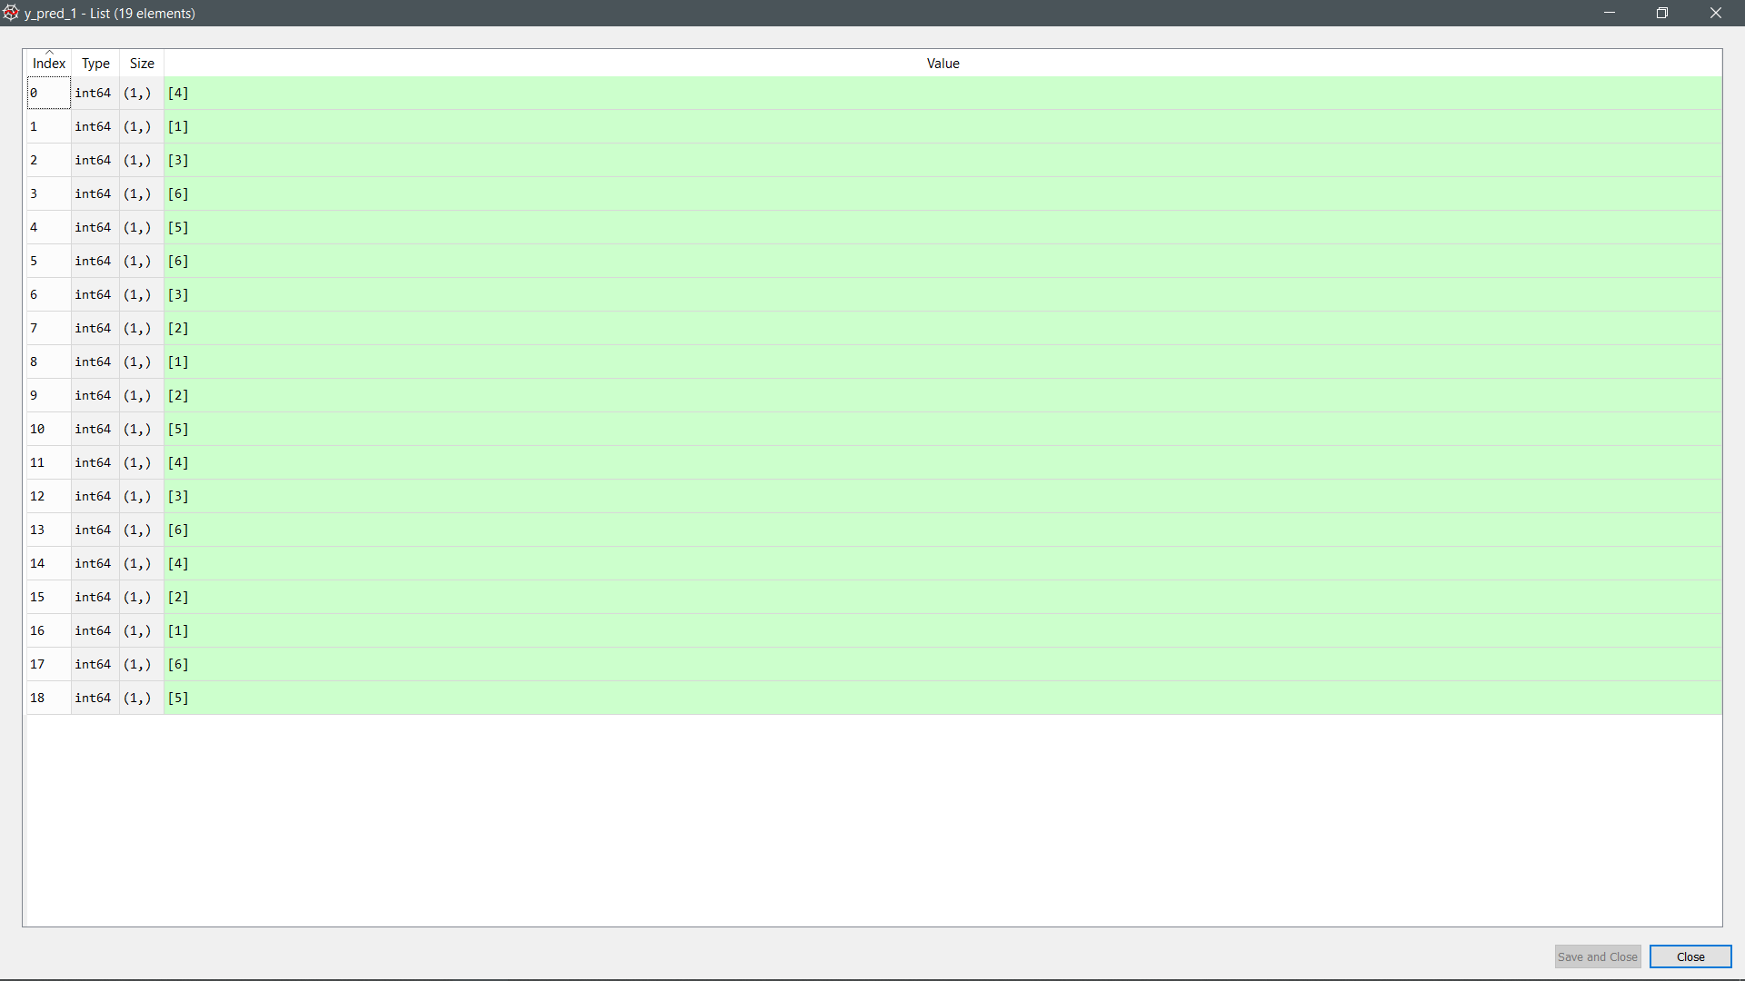

Prediction made by the model (Random Forest)

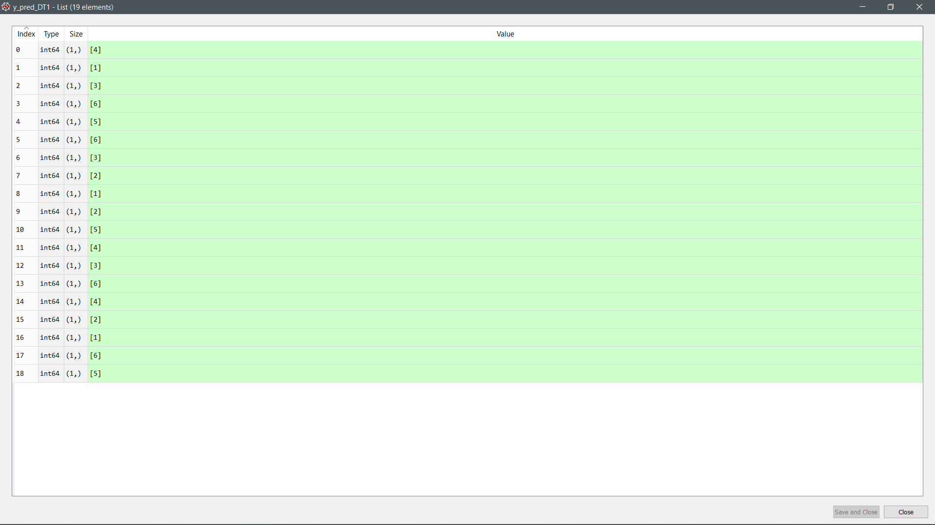

Prediction made by the model (Decision Tree)

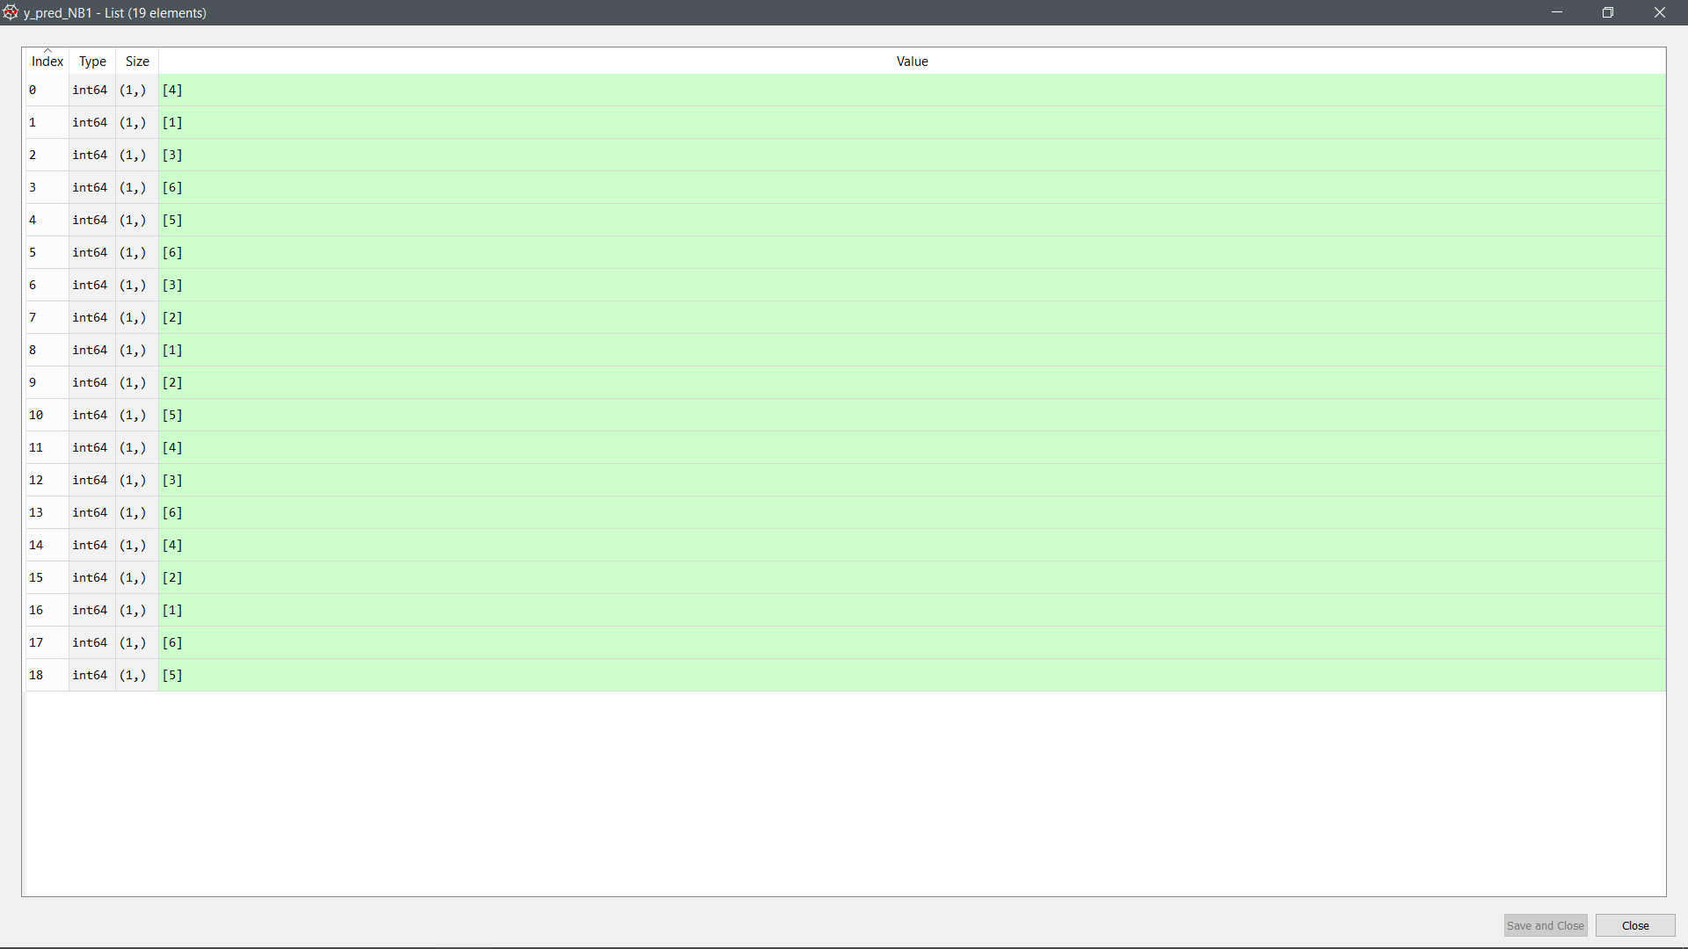

Prediction made by the model (Naive Bayes)

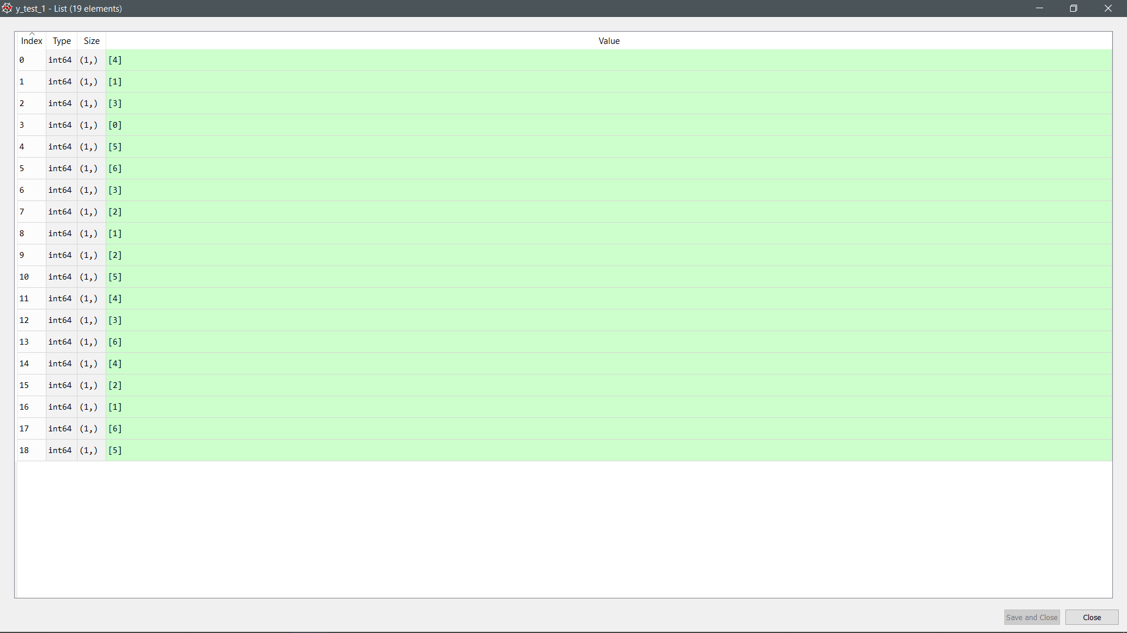

Actual value (Random Forest)

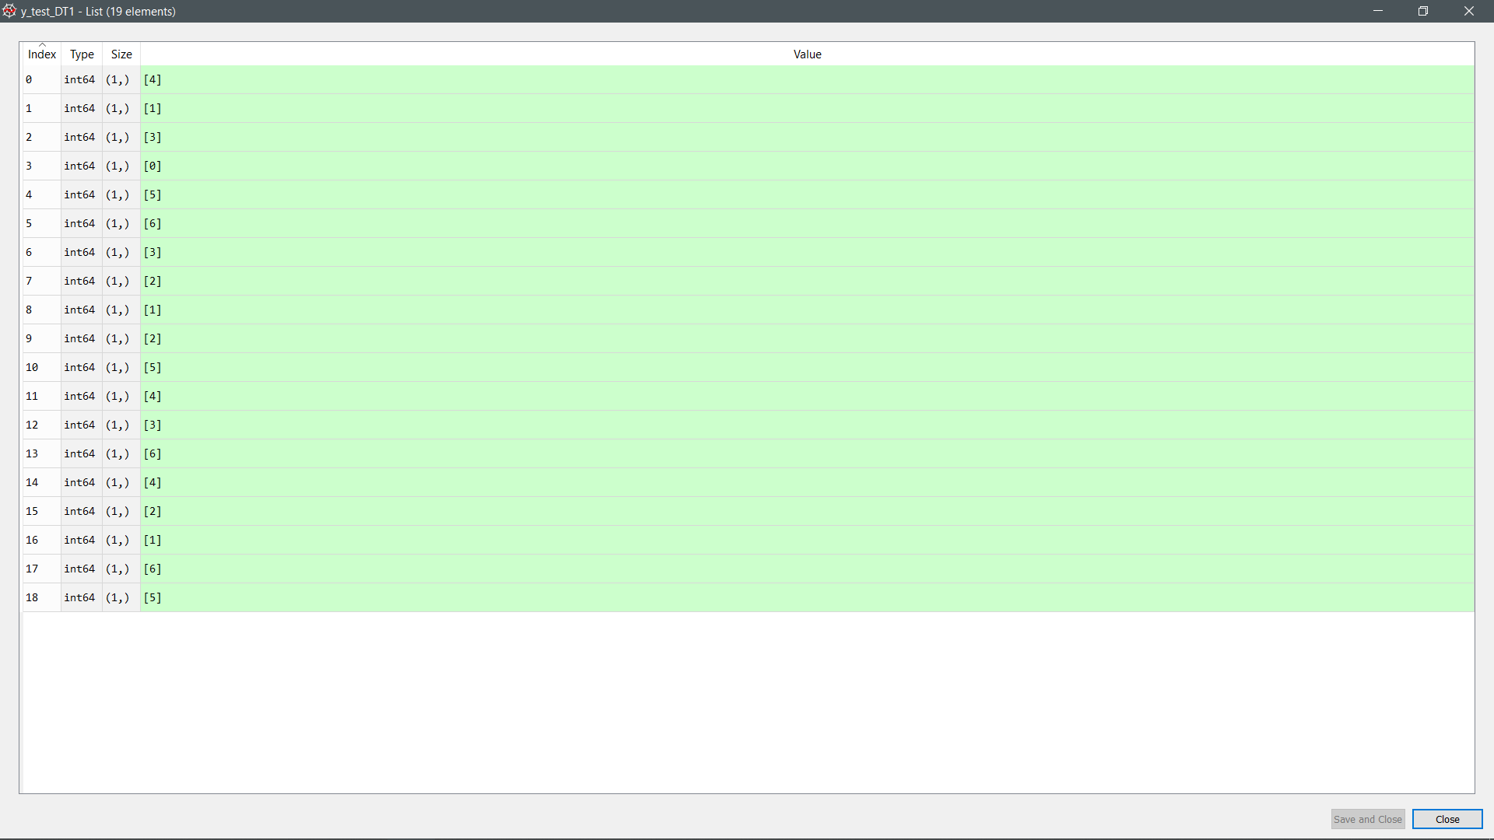

Actual value (Decision Tree

)



Actual value (Naïve Bayes)